IDB Lab 2

1. SELECT \* FROM DEPT;

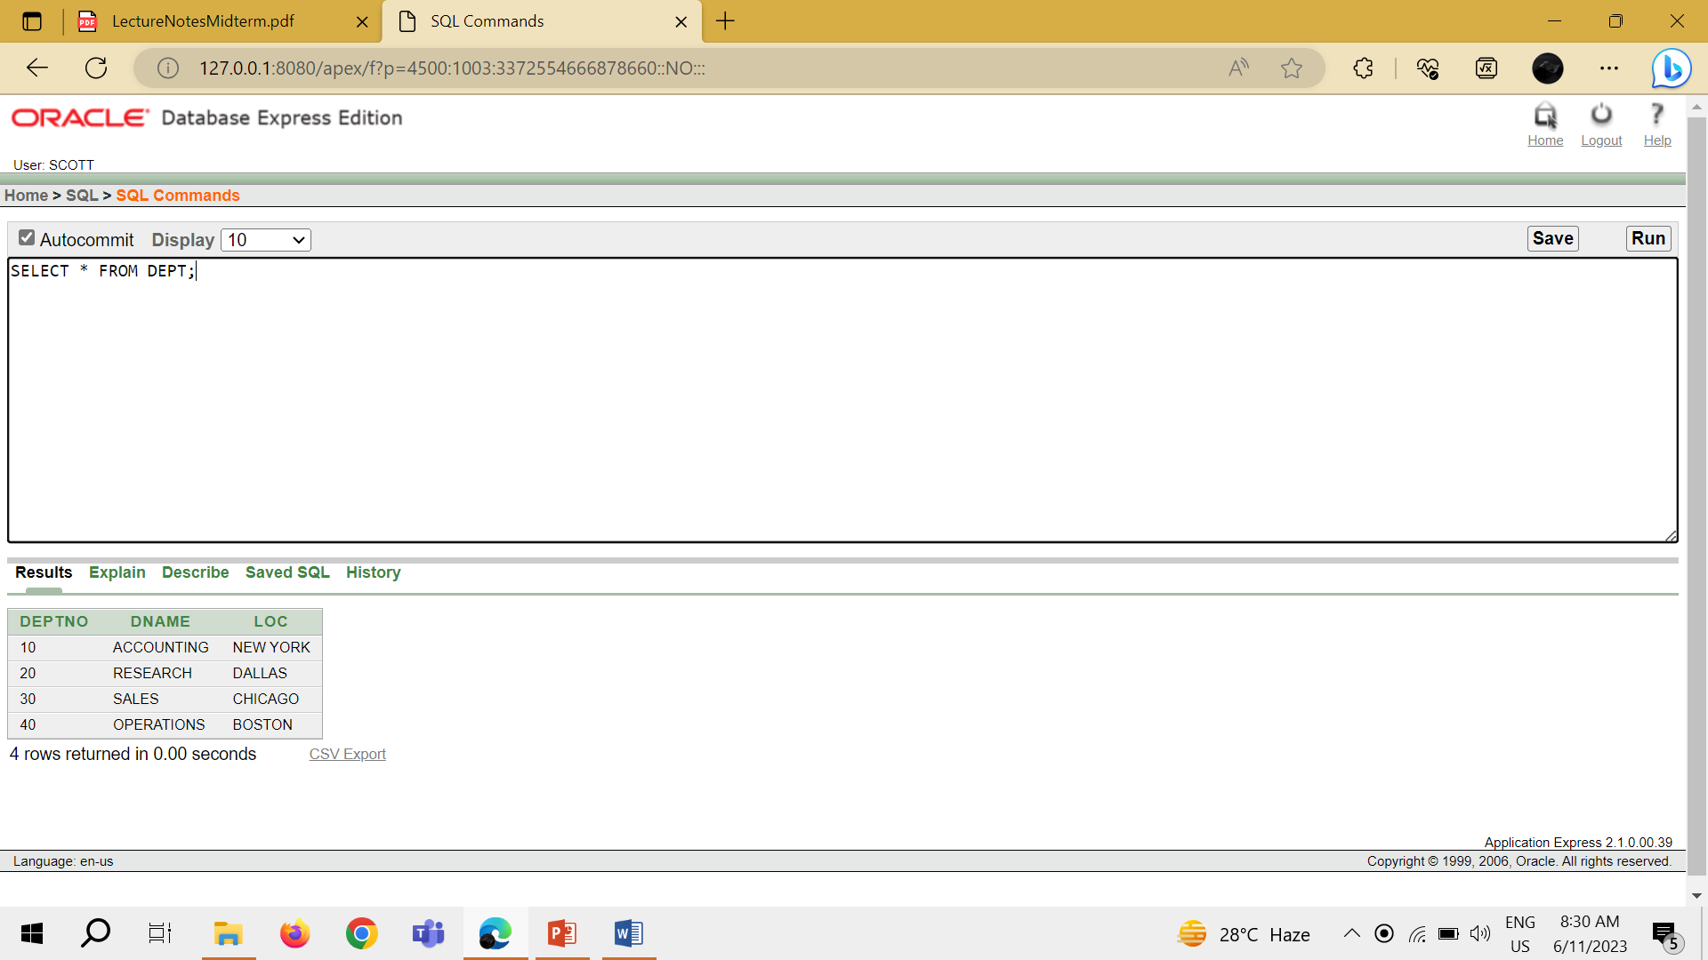

1. SELECT DEPTNO, LOC FROM DEPT;

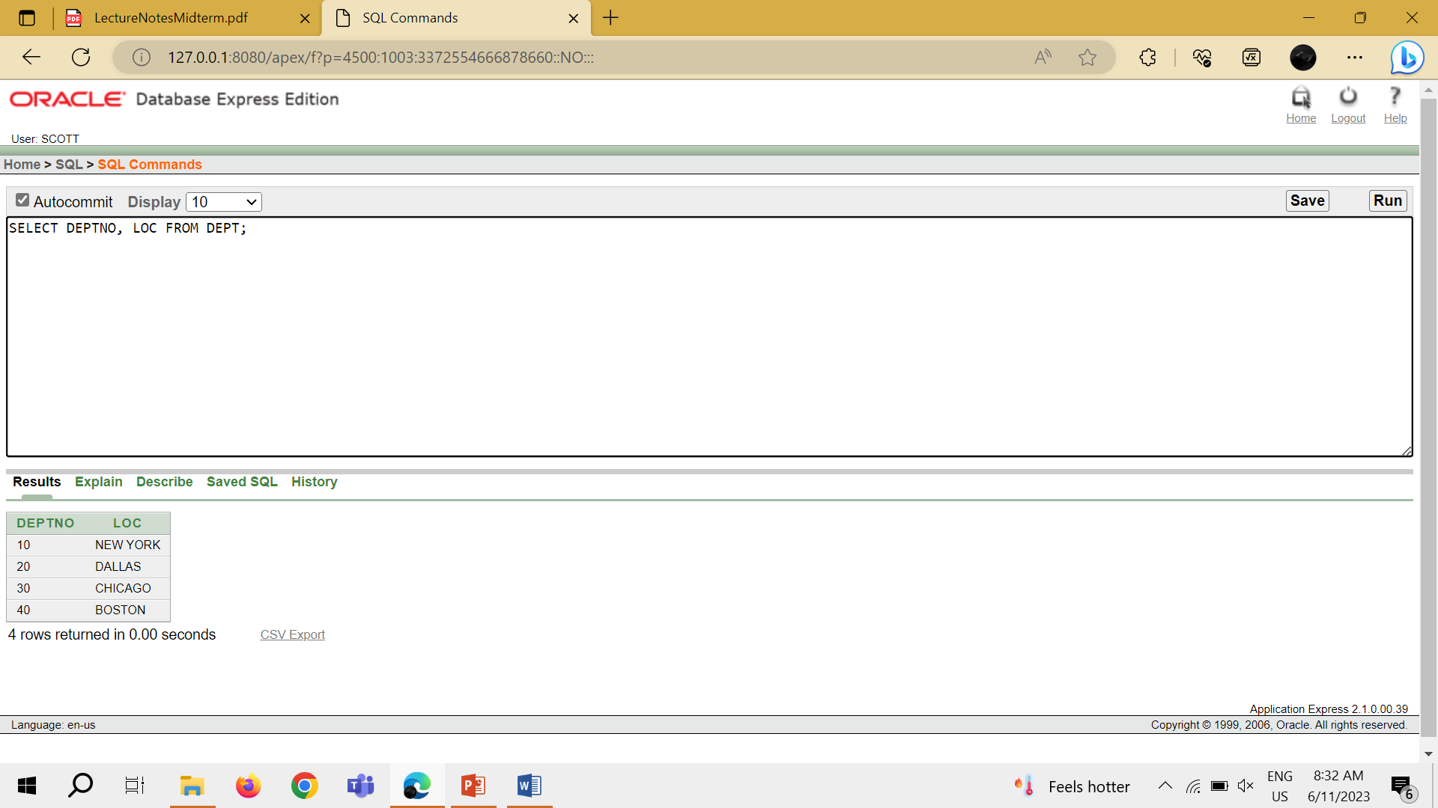

1. SELECT ENAME, SAL, SAL+300 FROM EMP;

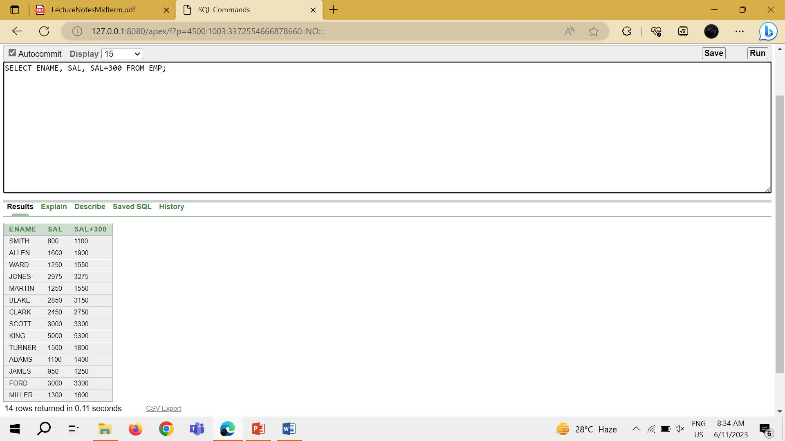

1. SELECT ENAME, SAL, 12\*SAL+100 FROM EMP;

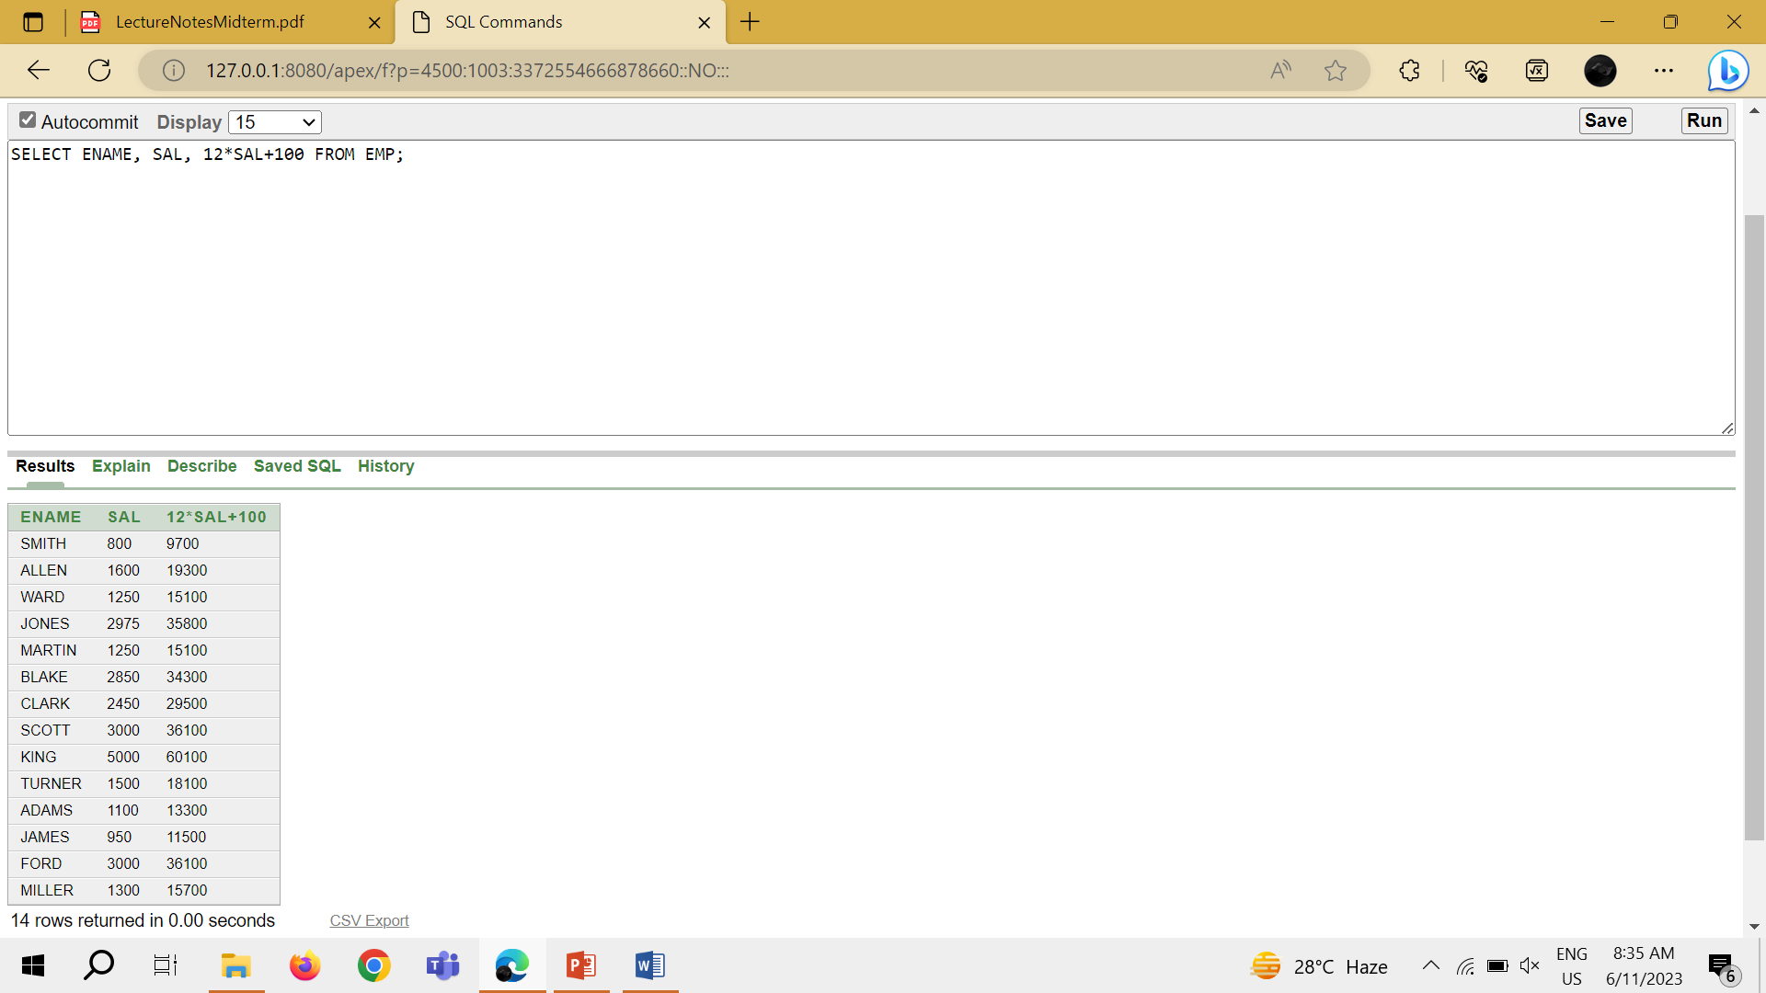

1. SELECT ENAME, SAL, 12\*(SAL+100) FROM EMP;

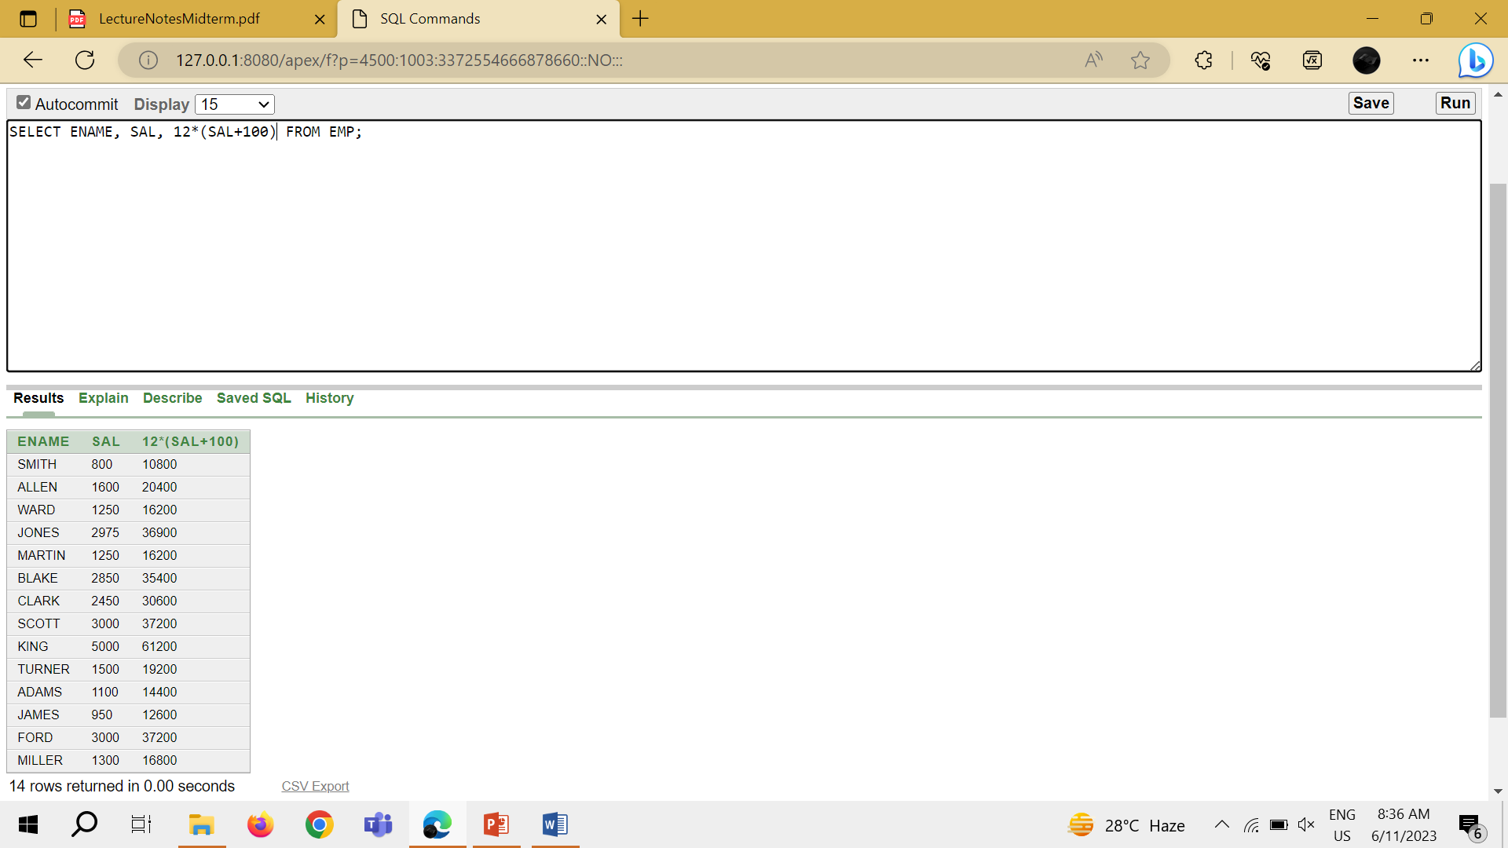

1. SELECT ENAME, JOB, COMM FROM EMP;

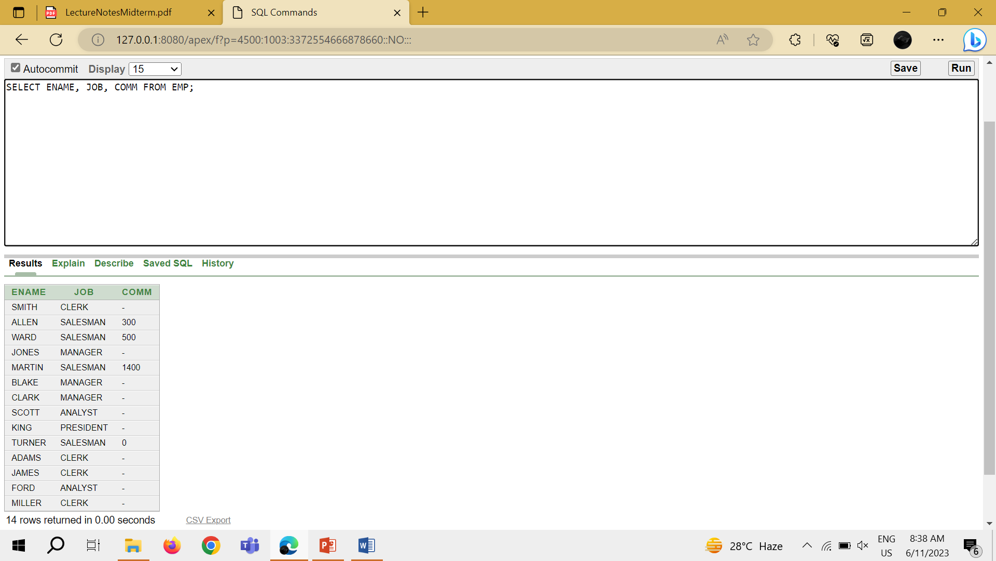

1. SELECT ENAME, 12\*SAL+COMM FROM EMP WHERE ENAME = 'KING';

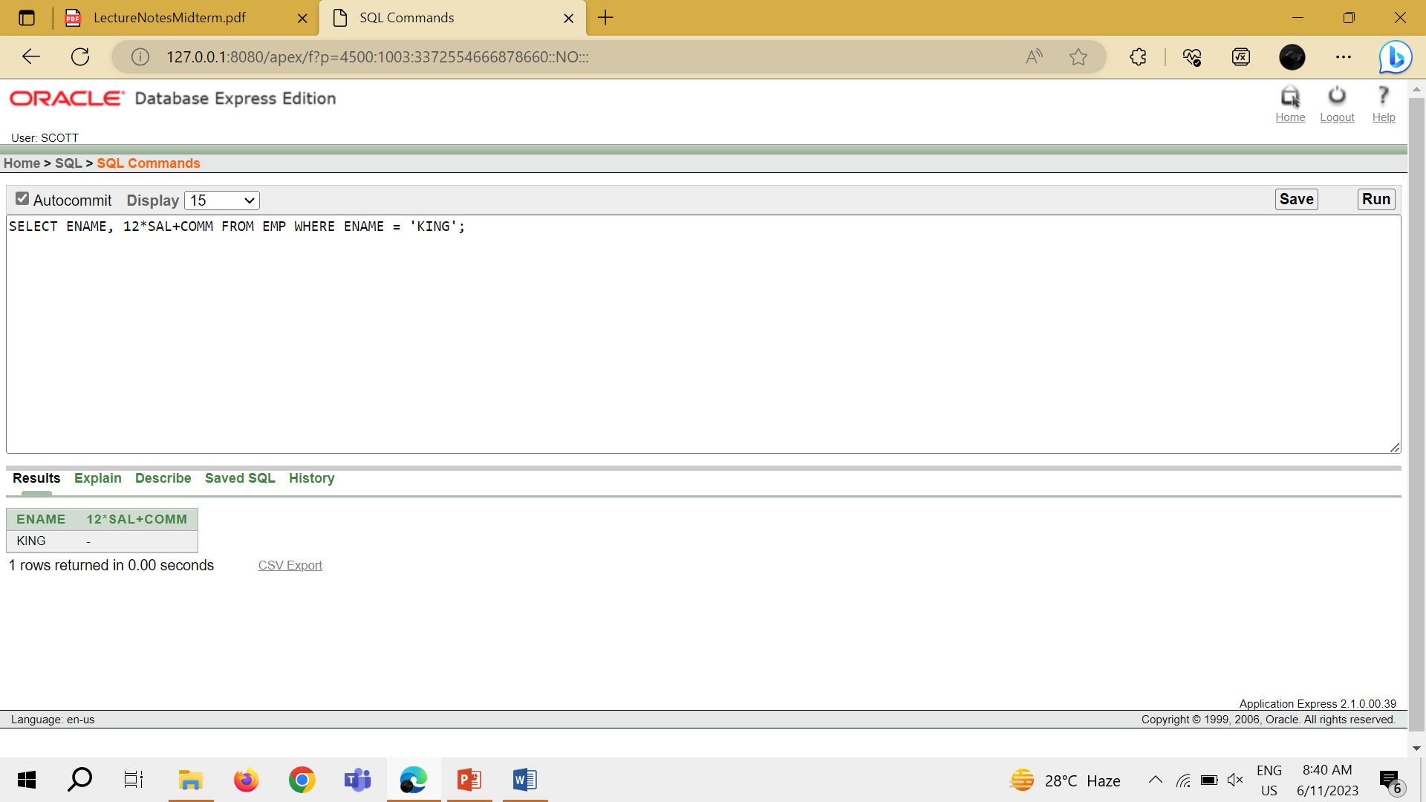

1. SELECT ENAME AS NAME, SAL SALARY FROM EMP;

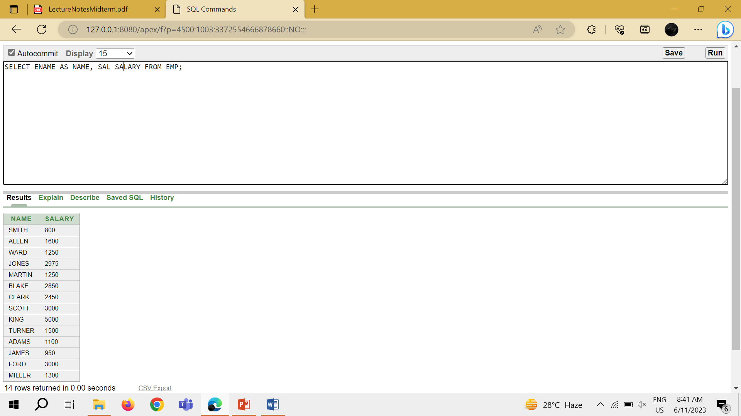

1. SELECT ENAME "NAME", SAL\*12 "ANNUAL SALARY" FROM EMP;

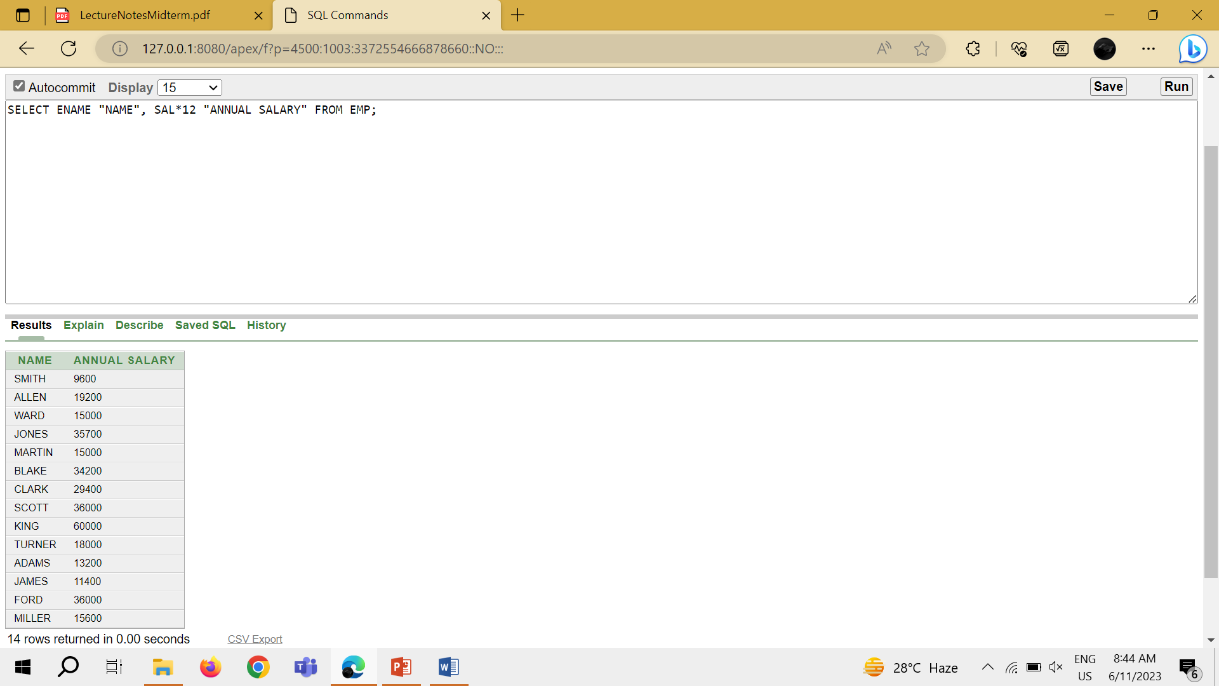

1. SELECT ENAME || JOB AS "EMPLOYEES" FROM EMP;

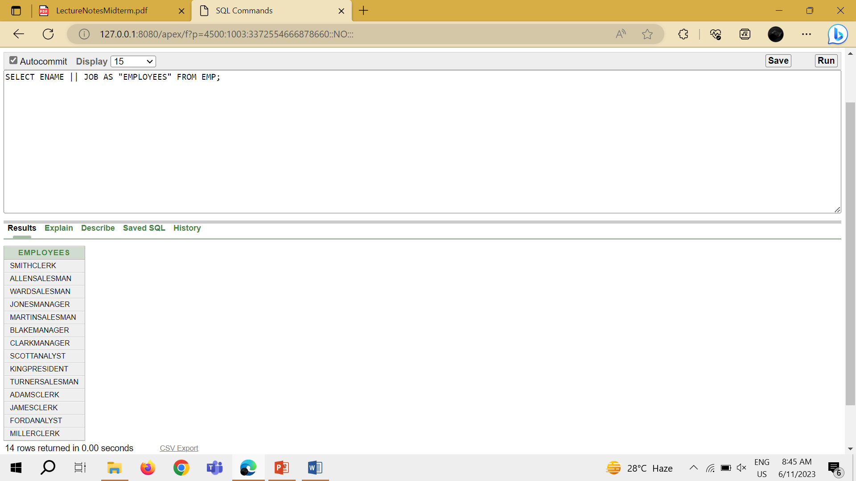

1. SELECT ENAME || ' ' || 'IS A' || ' ' || JOB AS "EMPLOYEE DETAILS" FROM EMP;

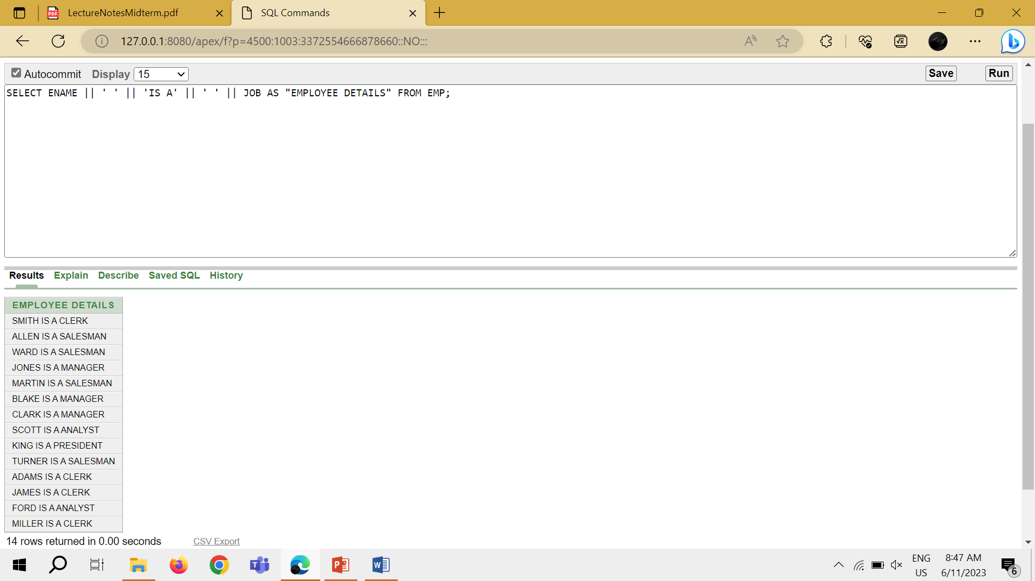

1. SELECT DEPTNO FROM EMP;

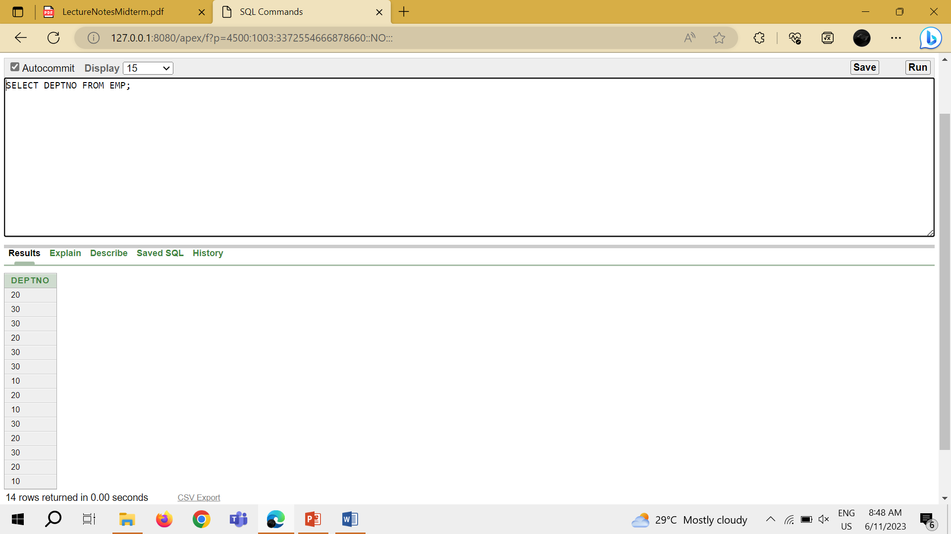

1. SELECT DISTINCT DEPTNO FROM EMP;

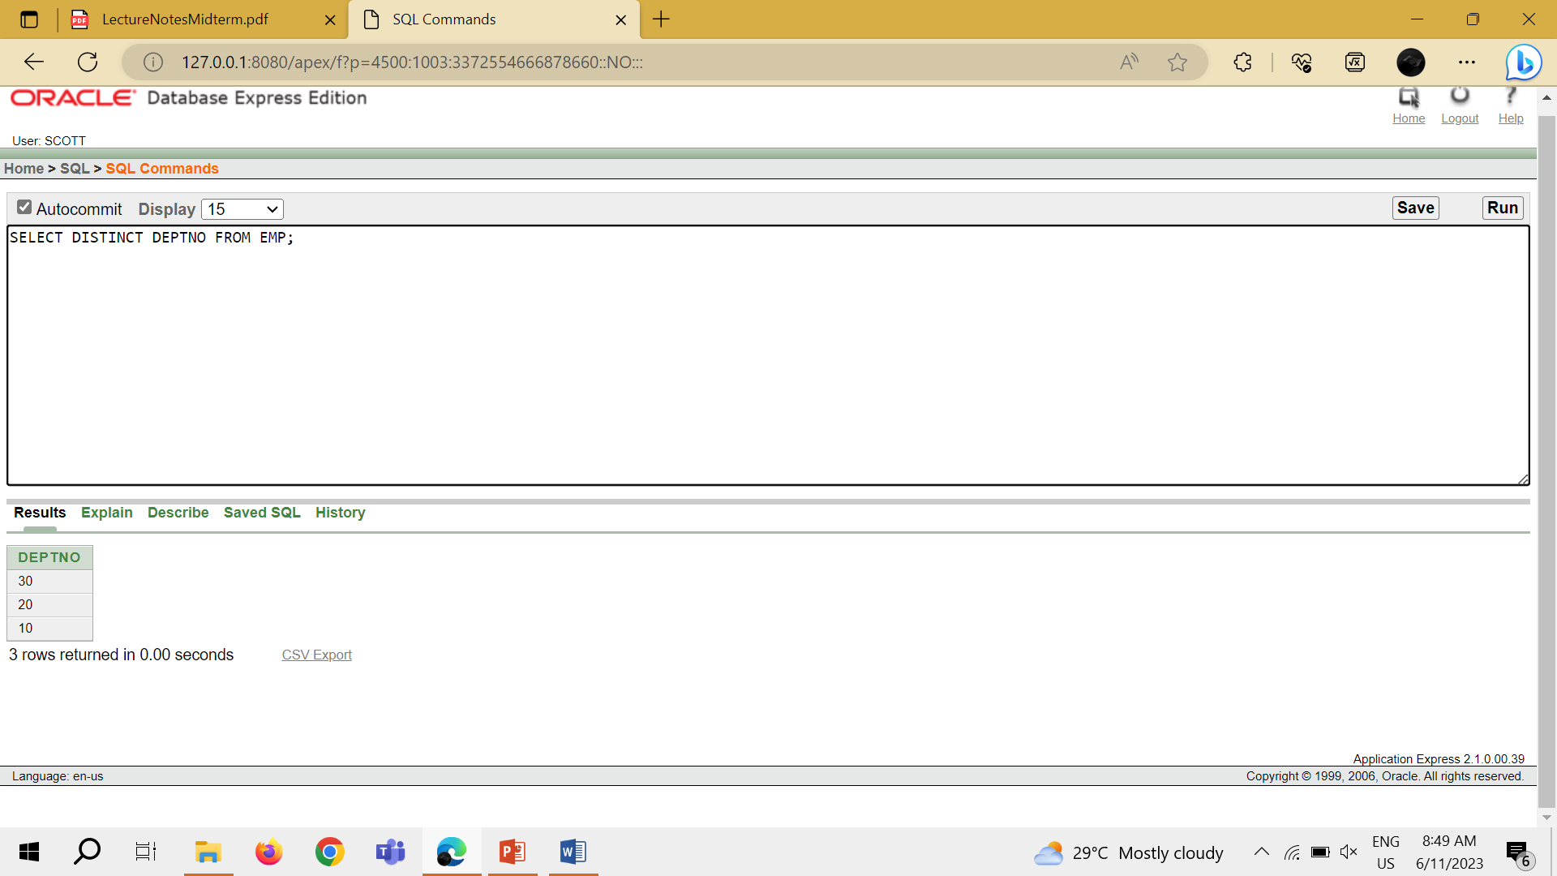

1. DESCRIBE DEPT;

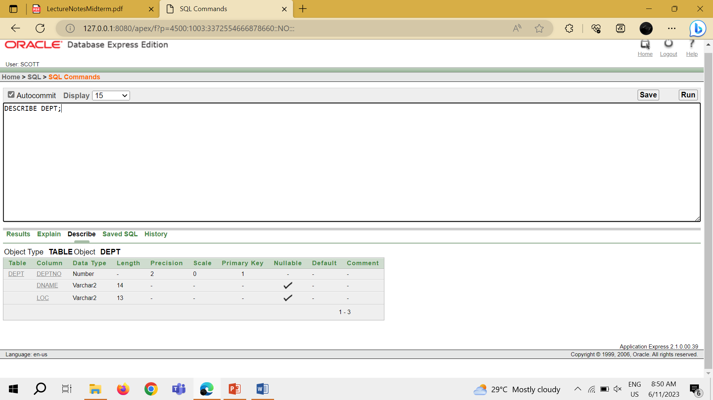

LAB TASK 1

1. SELECT ENAME, DEPTNO FROM EMP;

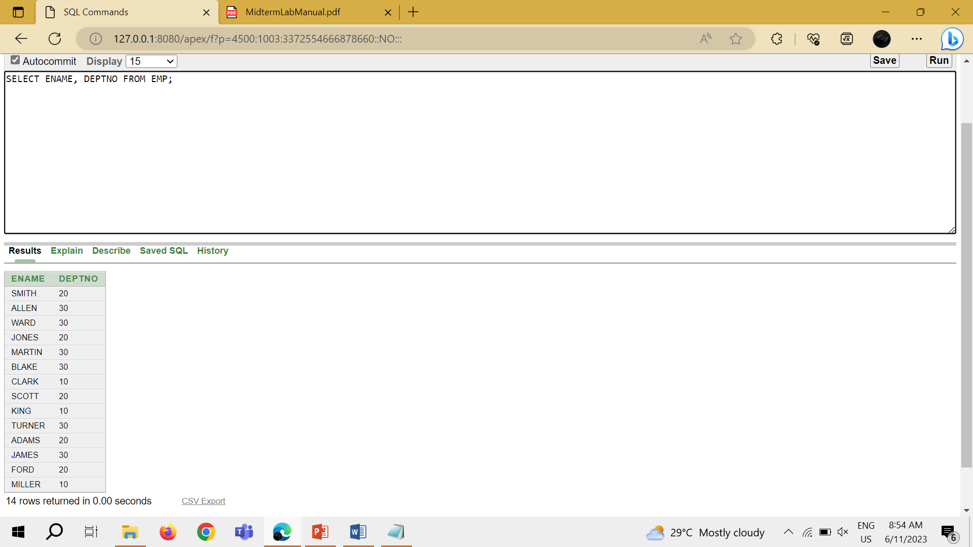

1. SELECT DISTINCT JOB FROM EMP WHERE DEPTNO = 30;

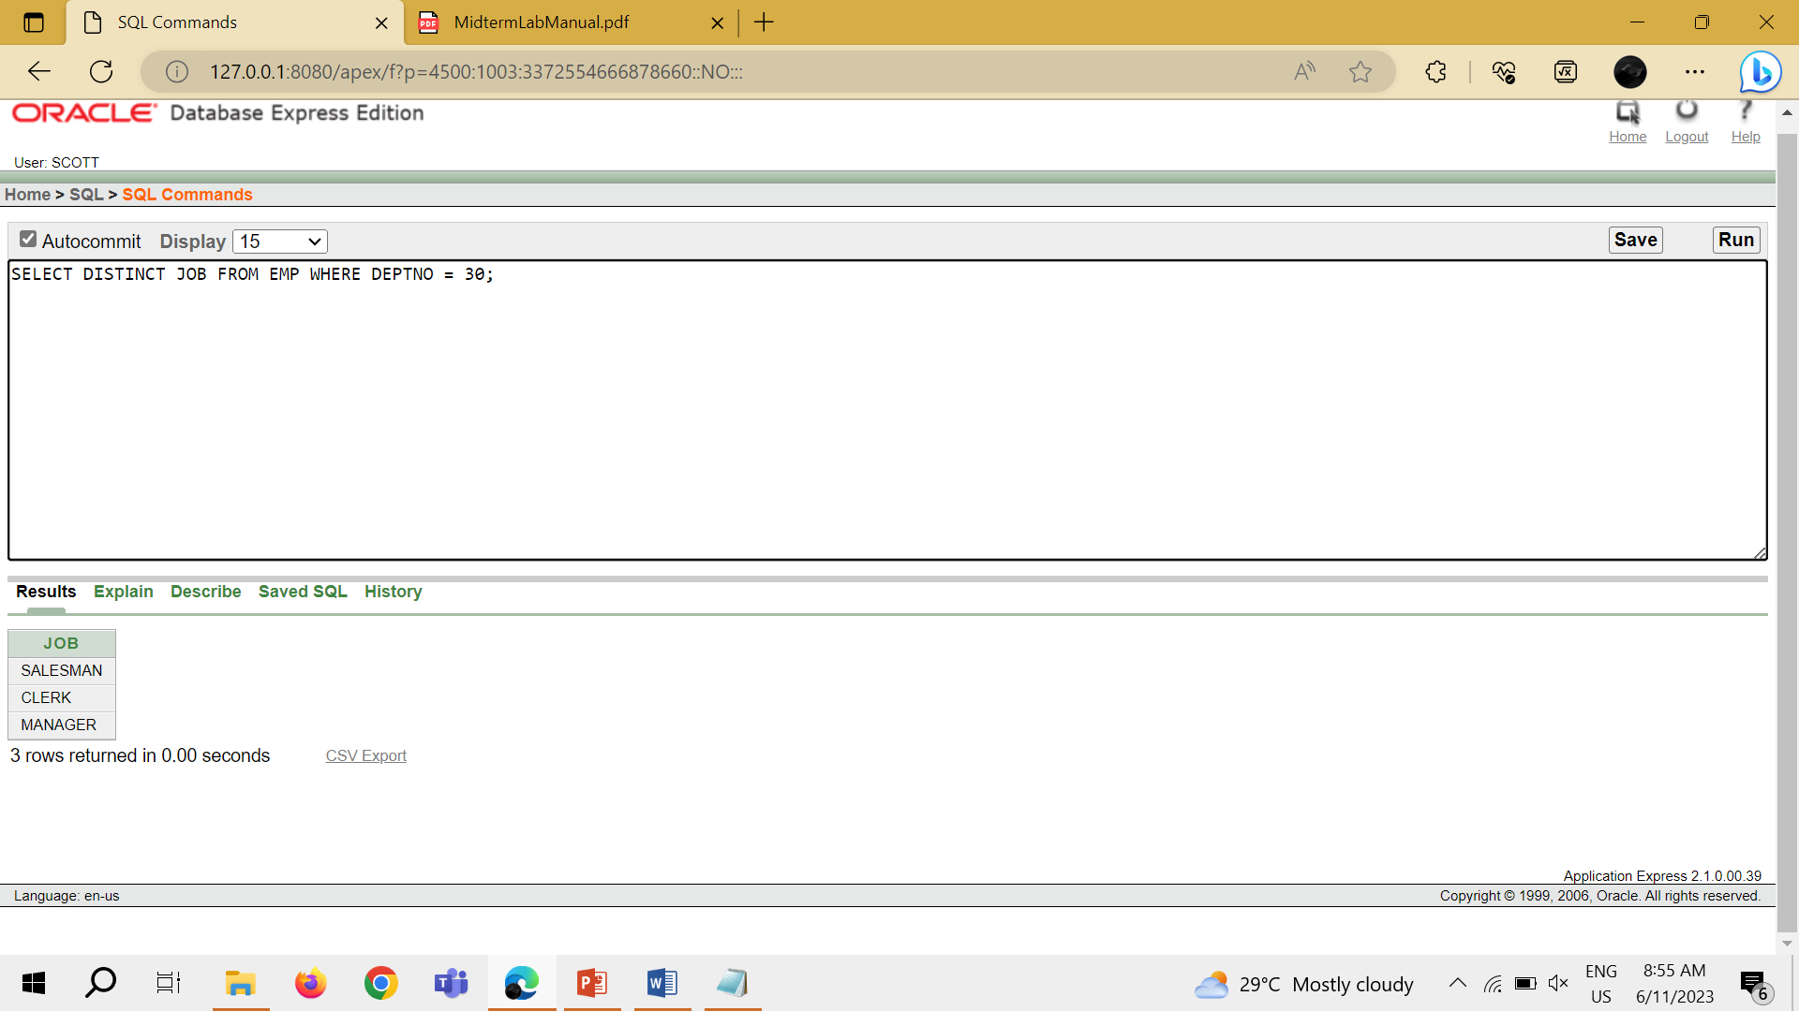

1. SELECT DISTINCT e.job, d.loc FROM emp e JOIN dept d ON e.deptno = d.deptno WHERE e.deptno = 30;

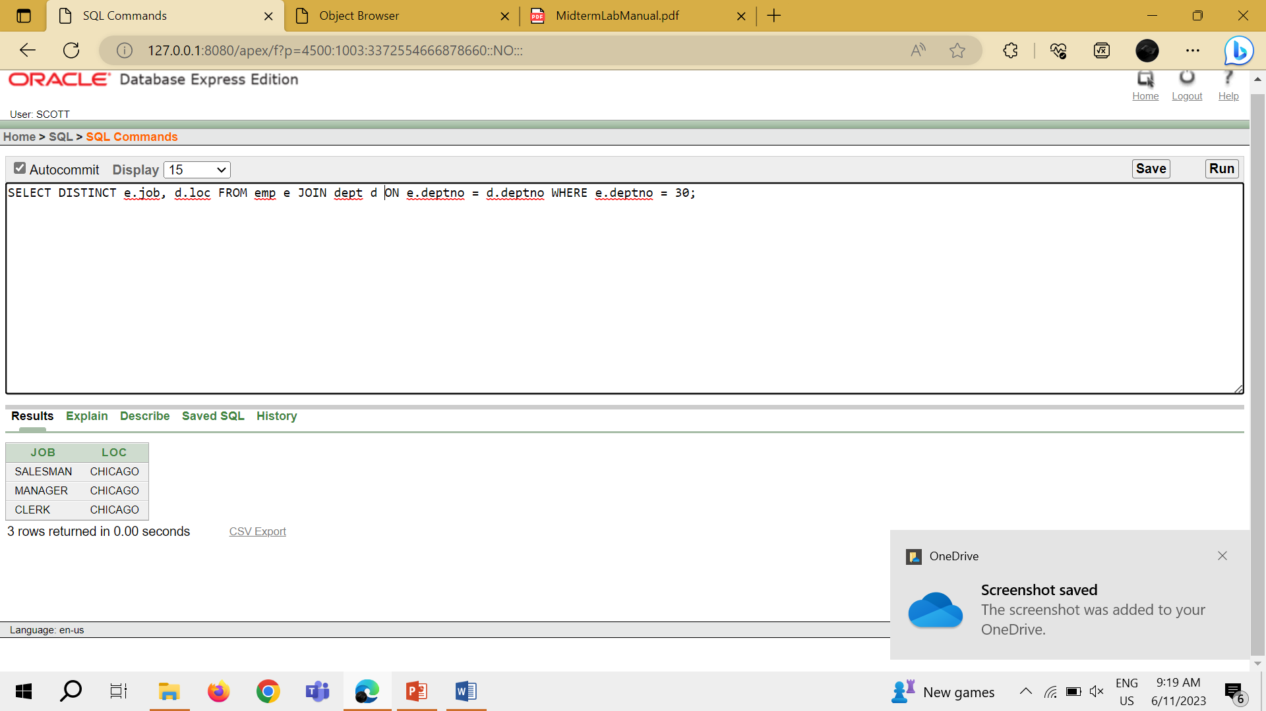

1. SELECT ENAME, EMPNO FROM EMP WHERE COMM IS NOT NULL;

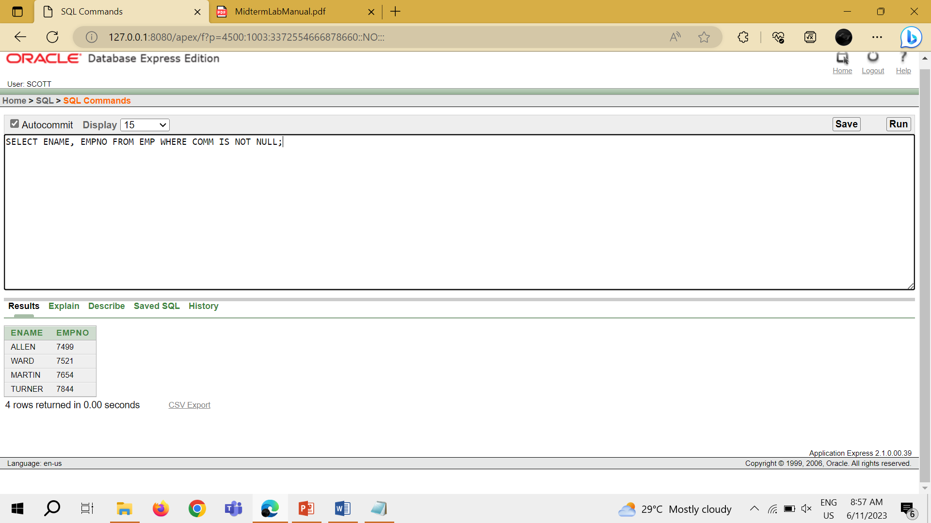

1. SELECT ENAME, DEPTNO FROM EMP WHERE ENAME LIKE '%A%';

